**Programming in Java**

**Prof. Debasis Samanta**

**Department of Computer Science and Engineering**

**Indian Institute of Technology, Kharagpur**

**Lecture - 50**

**JDBC – I**

Now, we shall start learning about JDBC. The full form of the JDBC is **Java Database Connectivity** and these concepts will be covered in 6 sessions including today. So far as the JDBC is concerned, there are three things to be learnt. First of all the database management system and then how the database management system can be connected. And, this itself is called the JDBC driver and then finally, the java application basically helps a programmer to connect a database from the application as an endpoint.

So, three things are there. As regards the database management system, there are many tools and many packages. In this course, we will cover one system which basically helps a programmer to maintain a database which is called the **MySQL.** So, we will now discuss the MySQL. MySQL is a database management system and now we will discuss how this MySQL can be installed. If you are new to this MySQL, then all this information is highly essential for your learning. So, I do not know exactly whether you are familiar with SQL or MySQL or any rather relational database management system.

Anyway so, considering that you do not have any background knowledge about the database management system handling, I will take a quick tour of the SQL based database management system which is a very popular one and called MySQL. So, in this session, we will try to learn about how the MySQL can be installed. And then finally, we will see exactly using this MySQL if once installed in your machine successfully, then how we can manage the database management system related to a task. We will also learn how we can create a database, how we can create a table under a database and then how we can accomplish different operations to the database.

(Refer Slide Time: 02:40)

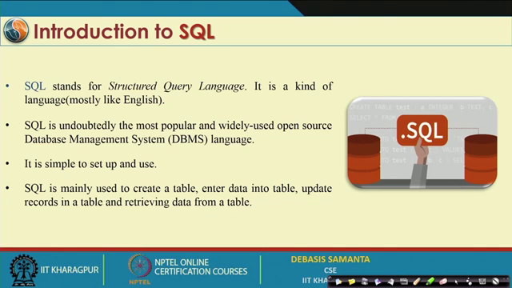

Now so, first what exactly is MySQL? It is a very popular software. Usually you know that the database management system provides for handling one language only and the standard language is called the **Structured Query Language**. We usually call this language as a fourth-generation language and if speak about C, C++, Java, they are the third generation language. SQL follows a certain syntax that is why it is sometimes called the language but truly SQL is not a language like Java, C, C++.

Anyway, SQL programming whatever it is there, we can do it in English like syntax actually. And it is basically a de-facto standard now-a-days. Every database management system engineer prefers the SQL based system. There are many types of database management systems as relational database management system and object-oriented database management systems. SQL is in fact, a relational database management system. Now, we will discuss a few things and few salient points about the relational database management system,